LPA3-NAVAIR Online Calibration Workflow
2025-05-13

TODO:
Firmware Release
Ensure PLA5 USB programmed to LPA3

FOR EACH UNIT
- Update firmware to
- Check appears as "LPA3" on connect dialog

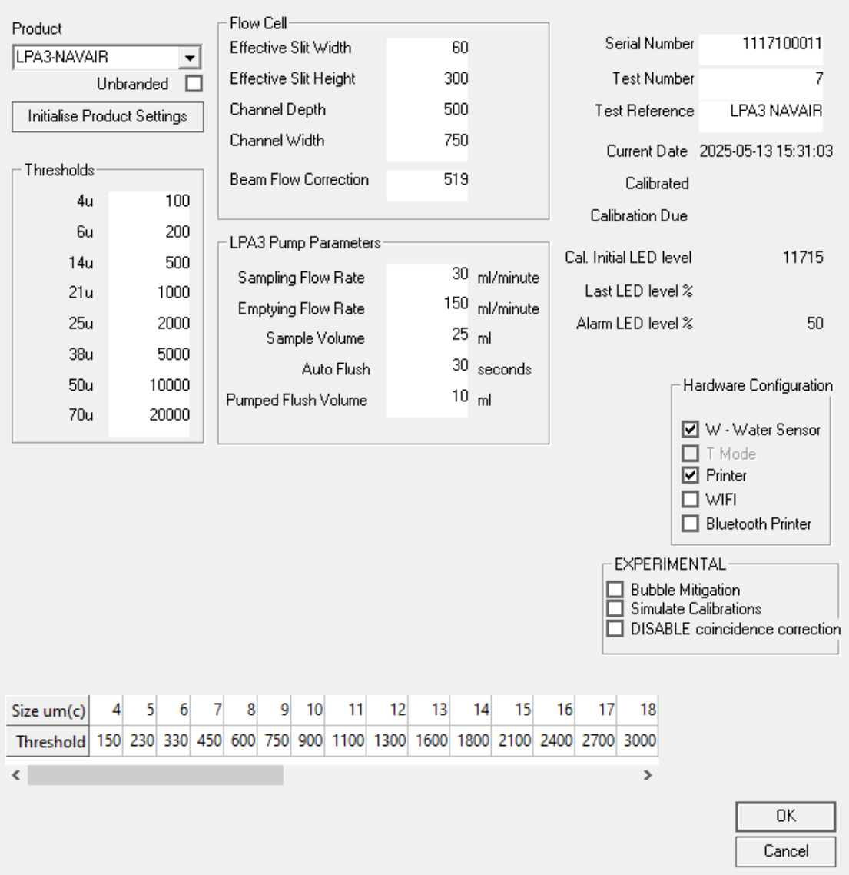
System Settings
- Change "Product" to LPA3-NAVAIR. Unit will reset.
- Initialise Product Settings
- Set serial number according to the one on the Block

Leave flushing with clean fluid for at least 20 minutes. Leave with fluid in unit for subsequent calibration.

Calibration
Setup
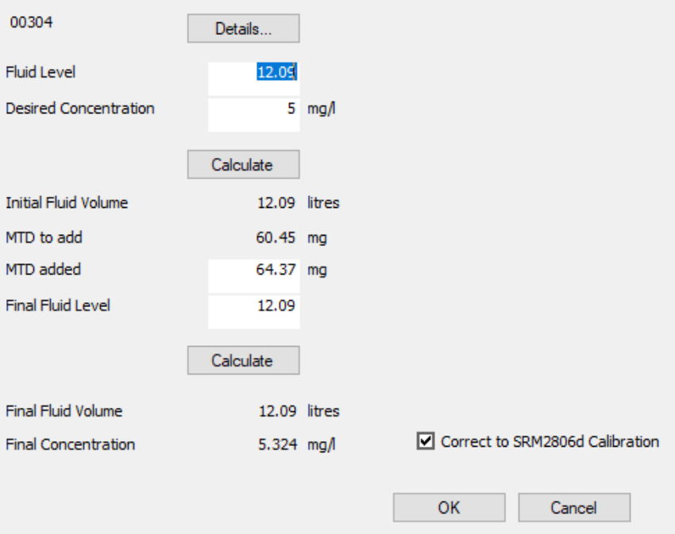
Use dialog to dose rig to 5mg/l MTD, "corrected" distribution tickbox on.
Distribution grid will populate and a line written to log indicating current target

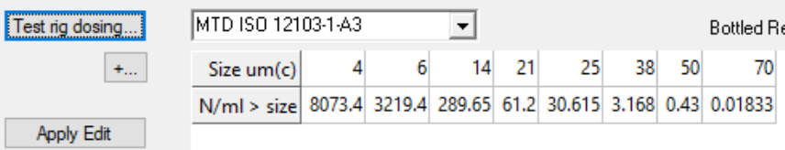

For Each Unit
Perform no-noise check a few times with clean fluid in block but test rig isolated (do this before calibration fluid through the unit.
Record Photocurrent and lowest noise value against serial number.
Connect to dosed test rig
Flush 100ml into waste
Flush for 1 minute
CAL START
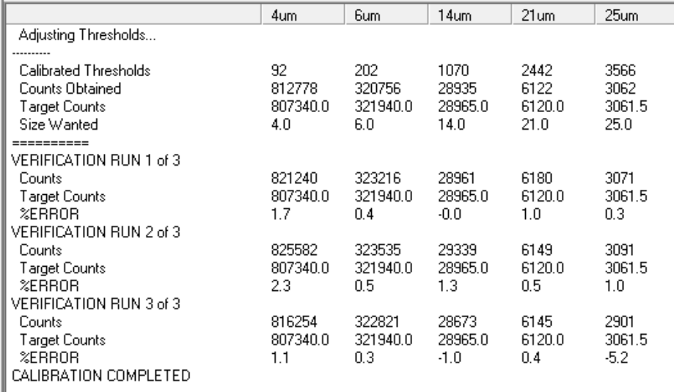
38+μm thresholds will not be reliable especially at 5mg/l
These need to be manually loaded from reference values.
As of 2025-05-13, thresholds for LPA3-NAVAIR are:
38μm | 9938
50μm(c) | 15300
70μm(c) | 25000

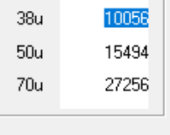
(CF automatically calibrated values)

